**PHOTO STORY: A DENTAL EMERGENCY**

Task 1. Read the dialogue and give a summary about it, and explain who they are.

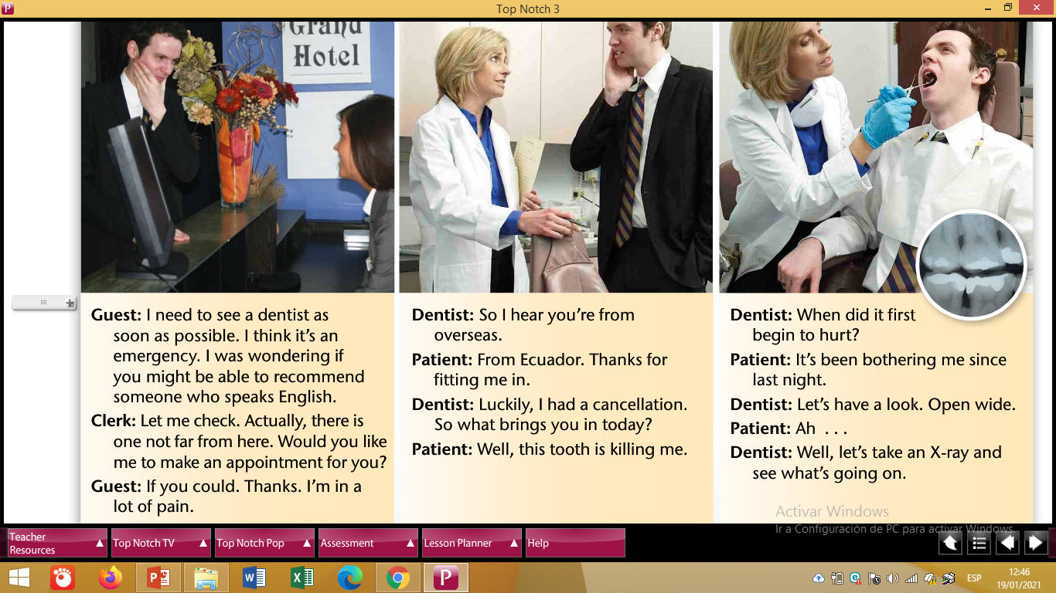

Task 2. Develop the activity C.

