**VOCABULARY 1 of UNIT 2**

**Task 1. Read and present the Vocabulary about SYMPTOMS.**

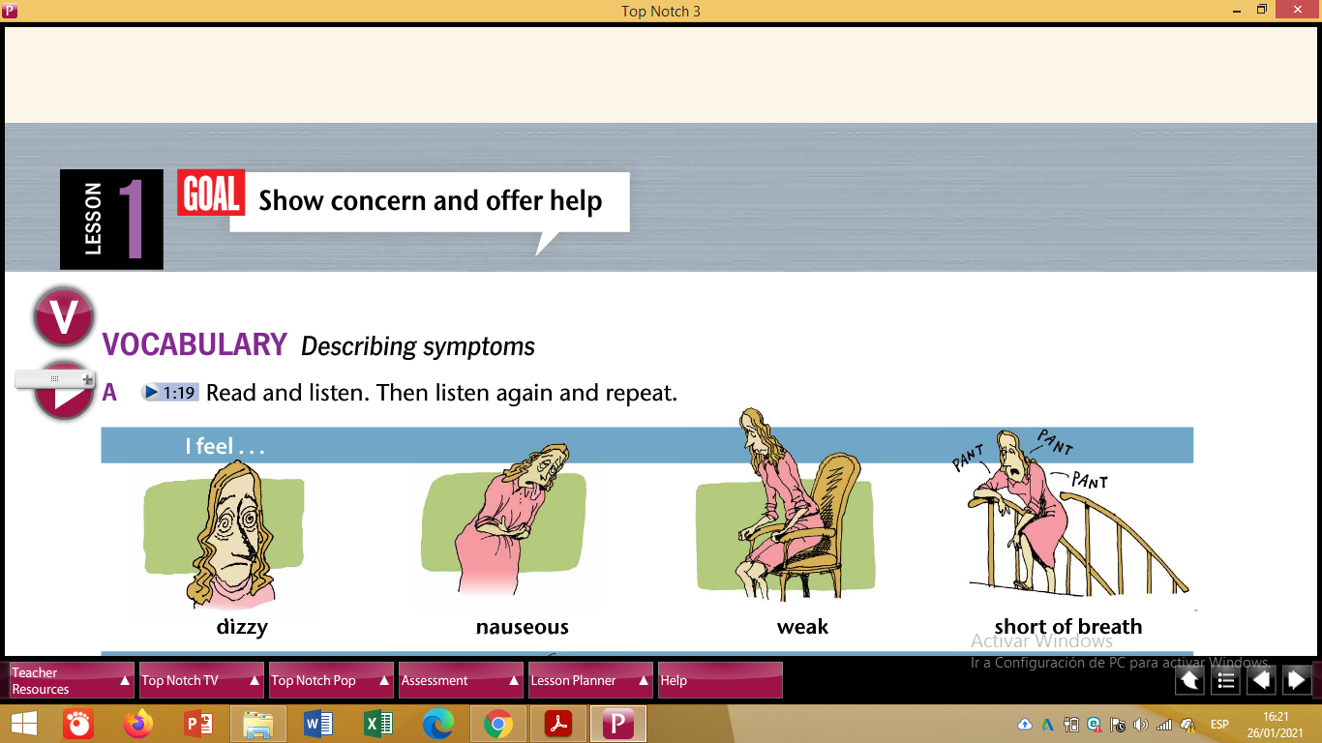

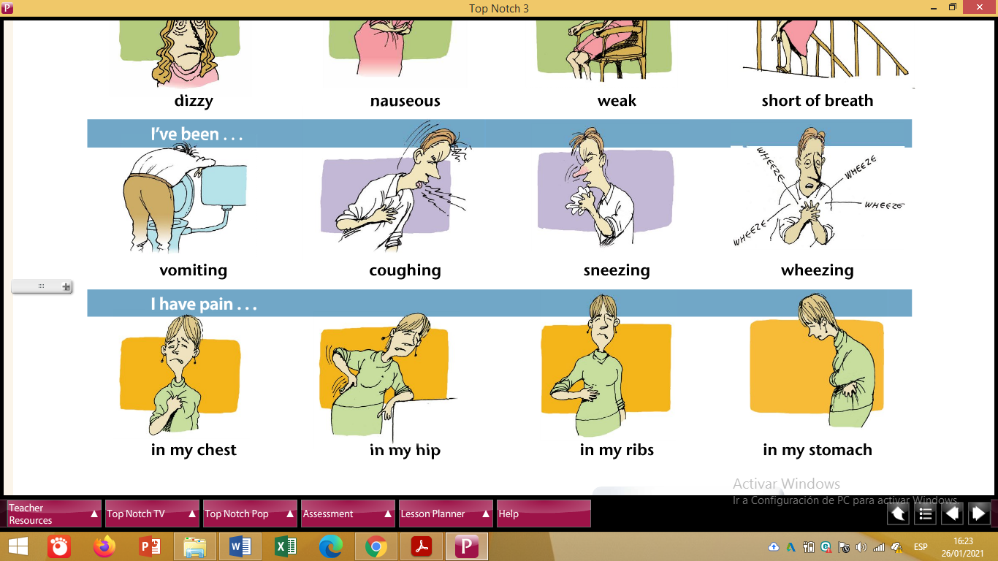

Task 2. Create a GAME for your partners to guess or complete the Vocabulary about SYMPTOMS.

Task 3. Describe SYMPTOMS to the doctor, in case you got …

1. A car accident
2. Pregnant
3. COVID

Use the expressions below to describe each condition:

* I feel … - I’ve been … - I have pain …

**Look at the example below.**

1. **A car accident:**

* **I feel weak.**
* **I’ve been vomiting.**
* **I have pain in my chest.**