**UNIT 3**

**NOW YOU CAN**

Task 1. Plan an event for your class. Complete the information on the table below.

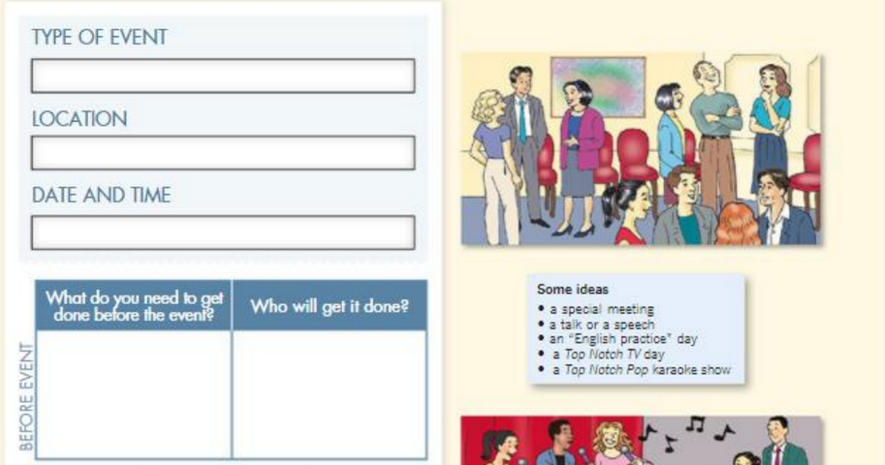

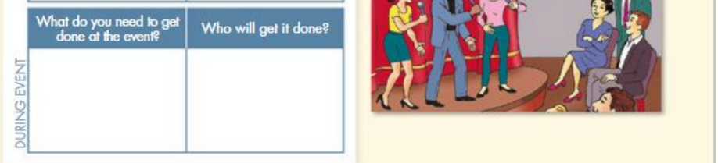

Task 2. Use Causative or Passive Causatives to explain how the event will be done.