**ADDITIONAL MATERIAL FOR DEVELOPING UNIT 1 LESSON 1**

### UNIT 1

### LIFE PLANS

##### UNIT LEARNING OUTCOMES

**Students will be able to:   
Explain a change of**[**intentions and plans**](https://moodle.unach.edu.ec/mod/url/view.php?id=1199041)**using was/were, going to and would to explain the reasons for changes.  
Express regrets about past actions using**[**perfect modals**](https://moodle.unach.edu.ec/mod/forum/view.php?id=1199046)**to talk about how things have been different.  
Discuss skills, abilities, and qualifications using specific vocabulary to ask and answer question on a job interview.  
Discuss factors that promote success using the target language to illustrate examples in the real life.**

The future in the past - "Was/Were going to"

#### Lesson 1. Explaining a change of intentions or plans

[English Grammar - The future in the past - "Was/Were going to" - YouTube](https://www.youtube.com/watch?v=sdL_Y-e-i6E&t=62s)

#### Lesson 2. Expressing regrets about past actions.





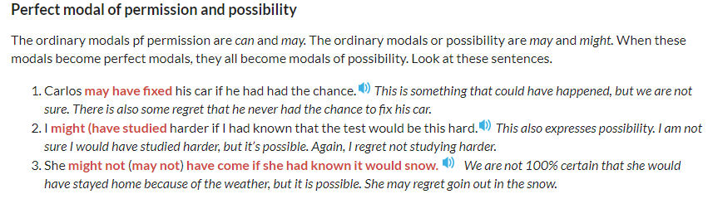

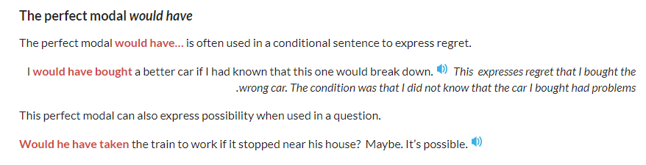

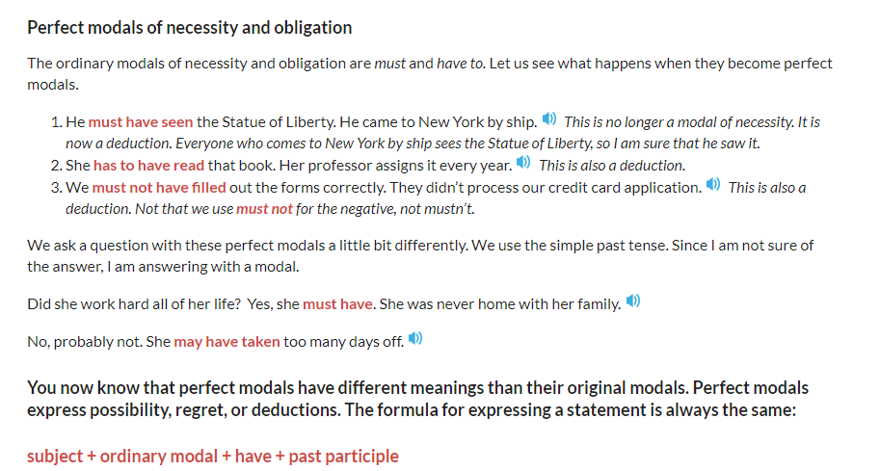

#### Lesson 3. Discussing  skills, abilities and qualifications

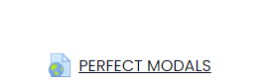

[Lesson on Could, Would, Should Have + Past Participle (I could have watched this lesson before) - YouTube](https://www.youtube.com/watch?v=GpfceXLIbgM)