* **Listen the song, and complete the midding words.**

<https://youtu.be/acvIVA9-FMQ?si=hOwxD4k6fnIbfbIA>

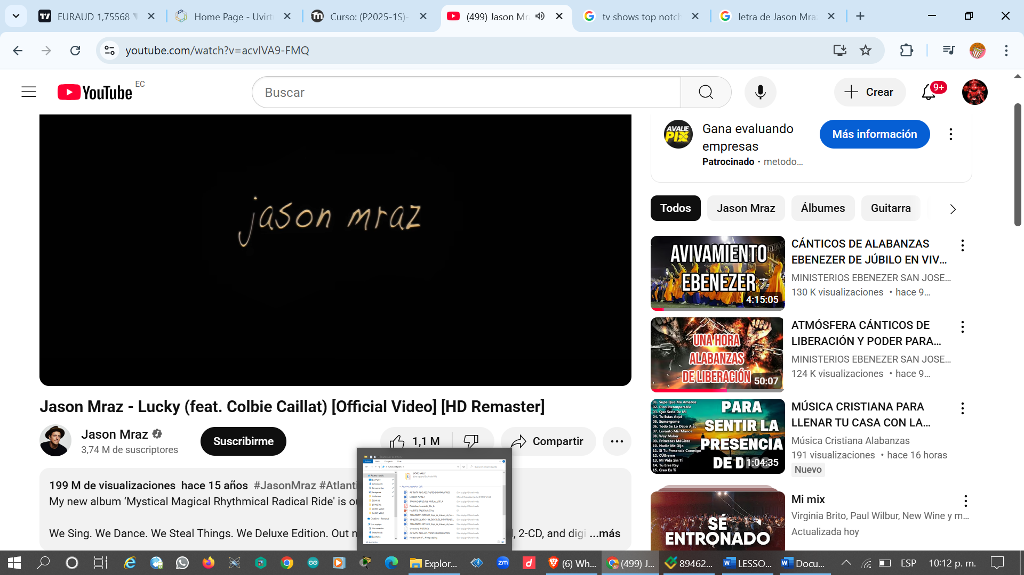

Do you hear me? I'm ………… to you  
……….. the water across the deep blue …………  
Under the open …….., oh my, baby, I'm trying  
Boy, I hear you in my dreams  
I feel your ……….. across the sea  
I keep you with me in my …………  
You make it ……… when life gets hard

Lucky I'm in love with my ……………….  
Lucky to have been where I have been  
Lucky to be ……… home again  
Ooh-ooh-ooh, ooh-ooh, ooh-ooh

They don't know how long it takes  
………….. for a love like …….  
Every time we say goodbye  
I wish we had one …… ………..  
I'll wait for you, I …….. you, I will

I'm lucky I'm in love with my ……………….  
Lucky to have been ……….. I have been  
Lucky to be coming home again  
Lucky we're in love in every way  
Lucky to have ………. where we have stayed  
Lucky to be coming home someday

And so I'm ………… through the sea  
To an island where we'll ………  
You'll hear the music fill the air  
I'll put a ……….. in your hair  
Though the ………., through the trees  
Move so ……… you're all I see  
As the world keeps …………… round  
You …….. me right here right now

Lucky I'm in ……… with my best friend  
Lucky to have been where I have ………  
Lucky to be coming home again  
I'm lucky we're in love in every way  
Lucky to have ……….. where we have stayed  
Lucky to be coming home someday

Ooh-ooh-ooh, ooh-ooh, ooh-ooh  
Ooh-ooh-ooh, ooh-ooh, ooh-ooh  
Ooh-ooh-ooh