**UNIT 1**

**READING**

Task 1. Read the text and get the main idea.

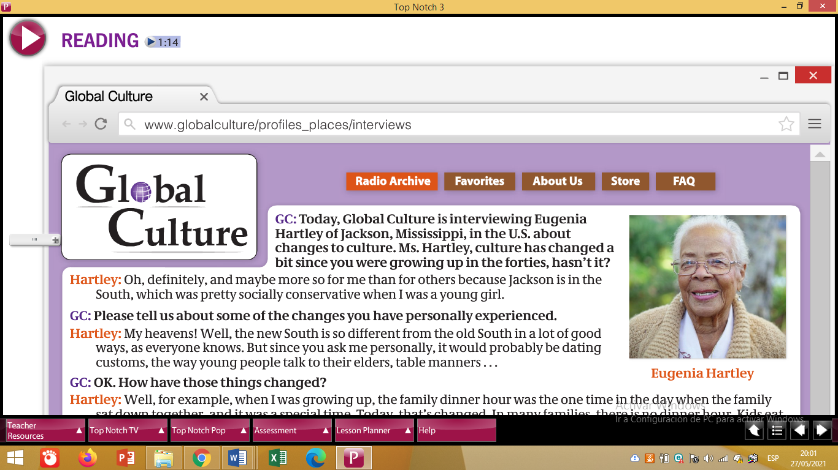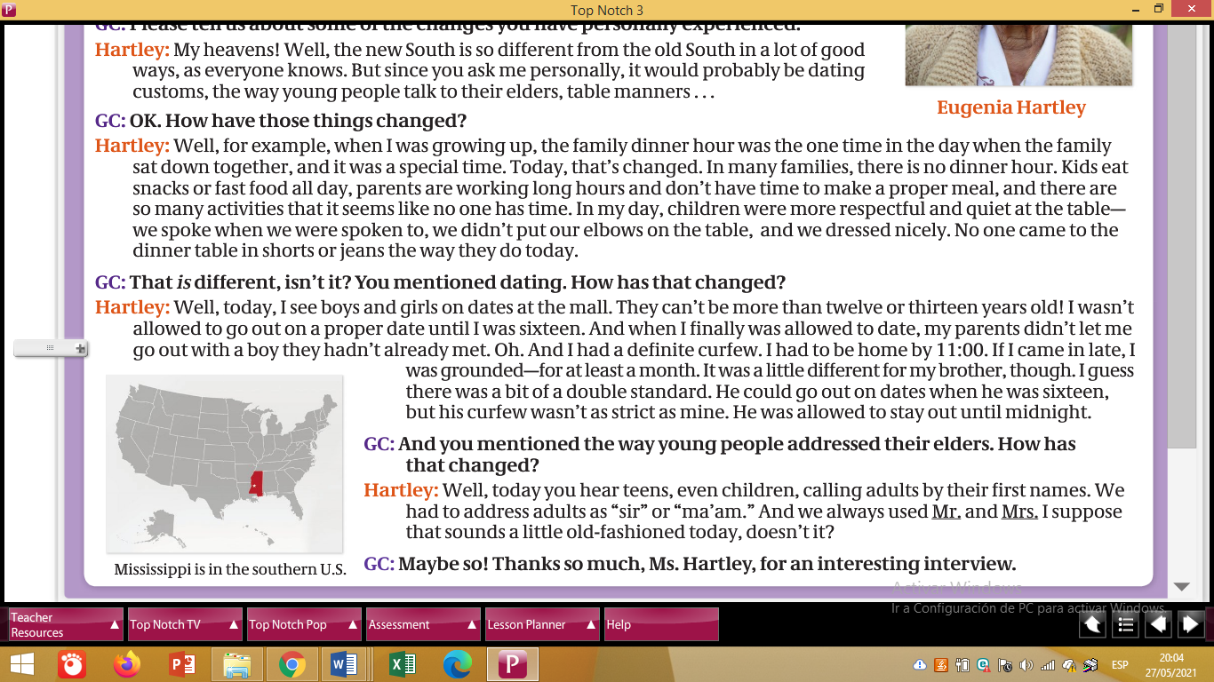

Task 2. Metion which topics Mrs. Hartley describes, complete this table.

|  |  |  |
| --- | --- | --- |
| **TOPIC/ASPECT** | **IN THE PAST** | **IN THE PRESENT** |
| Dating |  |  |
|  |  |  |
|  |  |  |
|  |  |  |
|  |  |  |