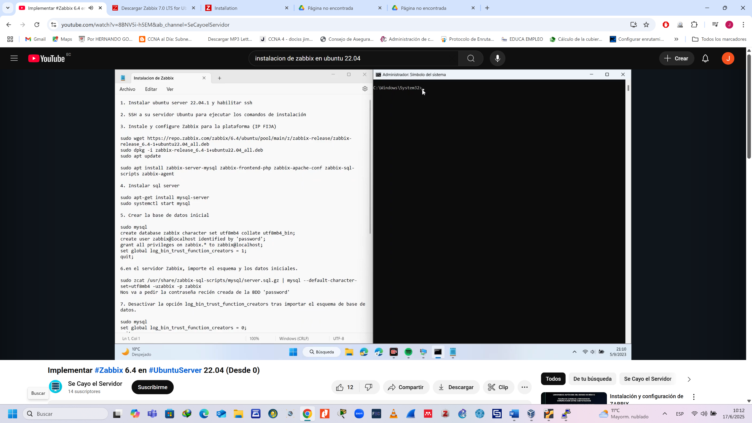

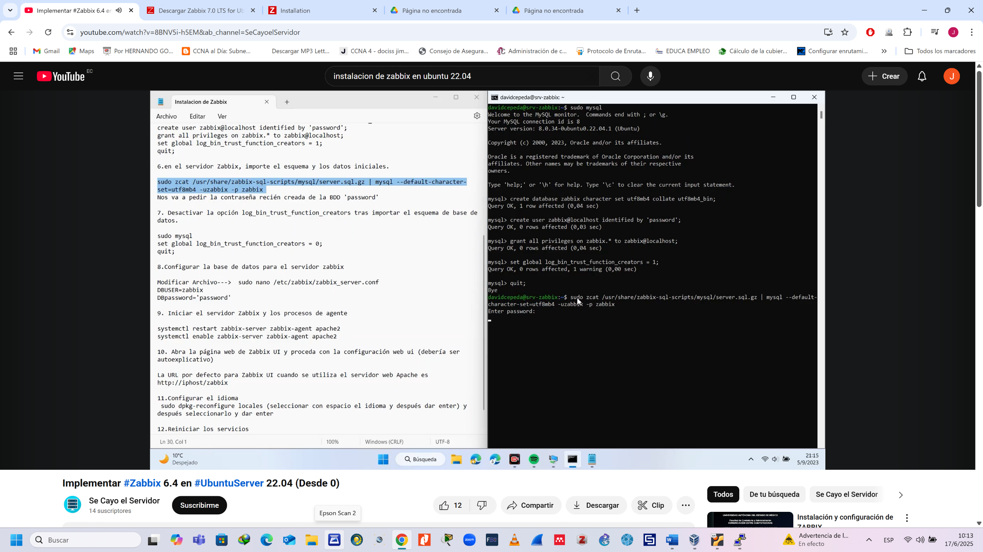

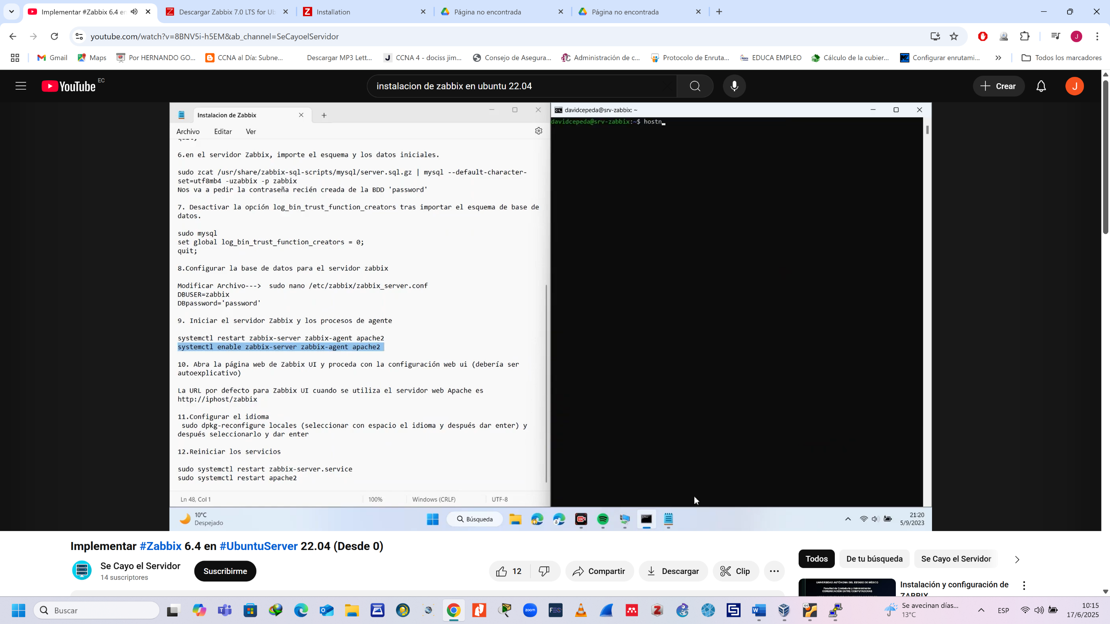

ssh nombreservidor@ 192.168.x.x

sudo wget <https://repo.zabbix.com/zabbix/6.4/ubuntu/pool/main/z/zabbix-release/zabbix-release_6.4-1+ubuntu22.04_all.deb>

sudo dpkg -i zabbix-release_6.4-1+ubuntu22.04_all.deb

sudo apt update

sudo apt install zabbix-server-mysql zabbix-frontend-php zabbix-apache-conf zabbix-sql-scripts zabbix-agent

sudo apt -get install mysql-server

sudo systemctl start mysql

sudo mysql

create database zabbix character set utf8mb4 collate utf8mb4_bin;

create user zabbix@localhost identified by 'password';

grant all privileges on zabbix.*to zabbix@localhost;

set global log_bin_trust_function_creators = 1;

quit;

sudo zcat /usr/share/zabbix-sql-scripts/mysql/server.sql.gz |mysql --default-character-set=utf8mb4 -uzabbix -p zabbix

sudo mysql

set global log_bin_trust_function_creators = 0;

quit;

sudo nano /etc/zabbix/zabbix_server.conf

systemctl restart zabbix-server zabbix-agent apache2

systemctl enable zabbix-server zabbix-agent apache2

sudo dpkg-reconfigure locales

sudo systemctl restart zabbix-server-service

sudo systemctl restart apache2

<https://linuxconfig.org/ubuntu-22-04-download>

https://linuxconfig.org/ubuntu-22-04-download