**PAST TENSE REGULAR VERBS**

**PRONUNCIATION**

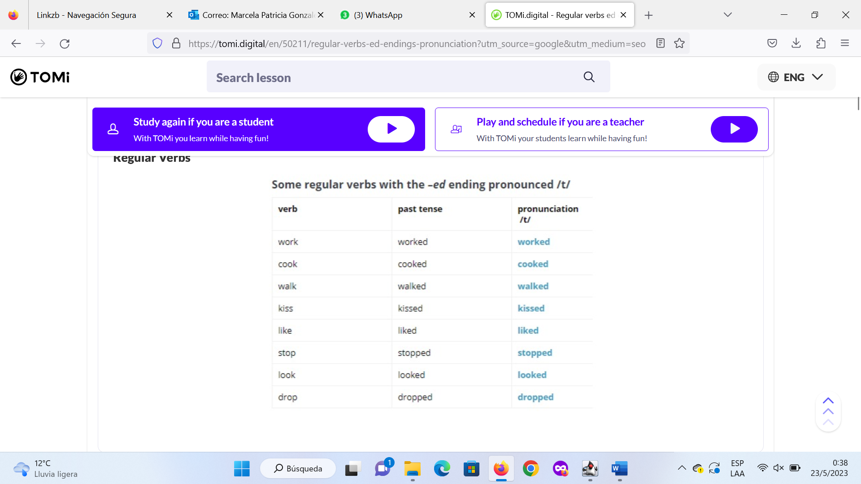

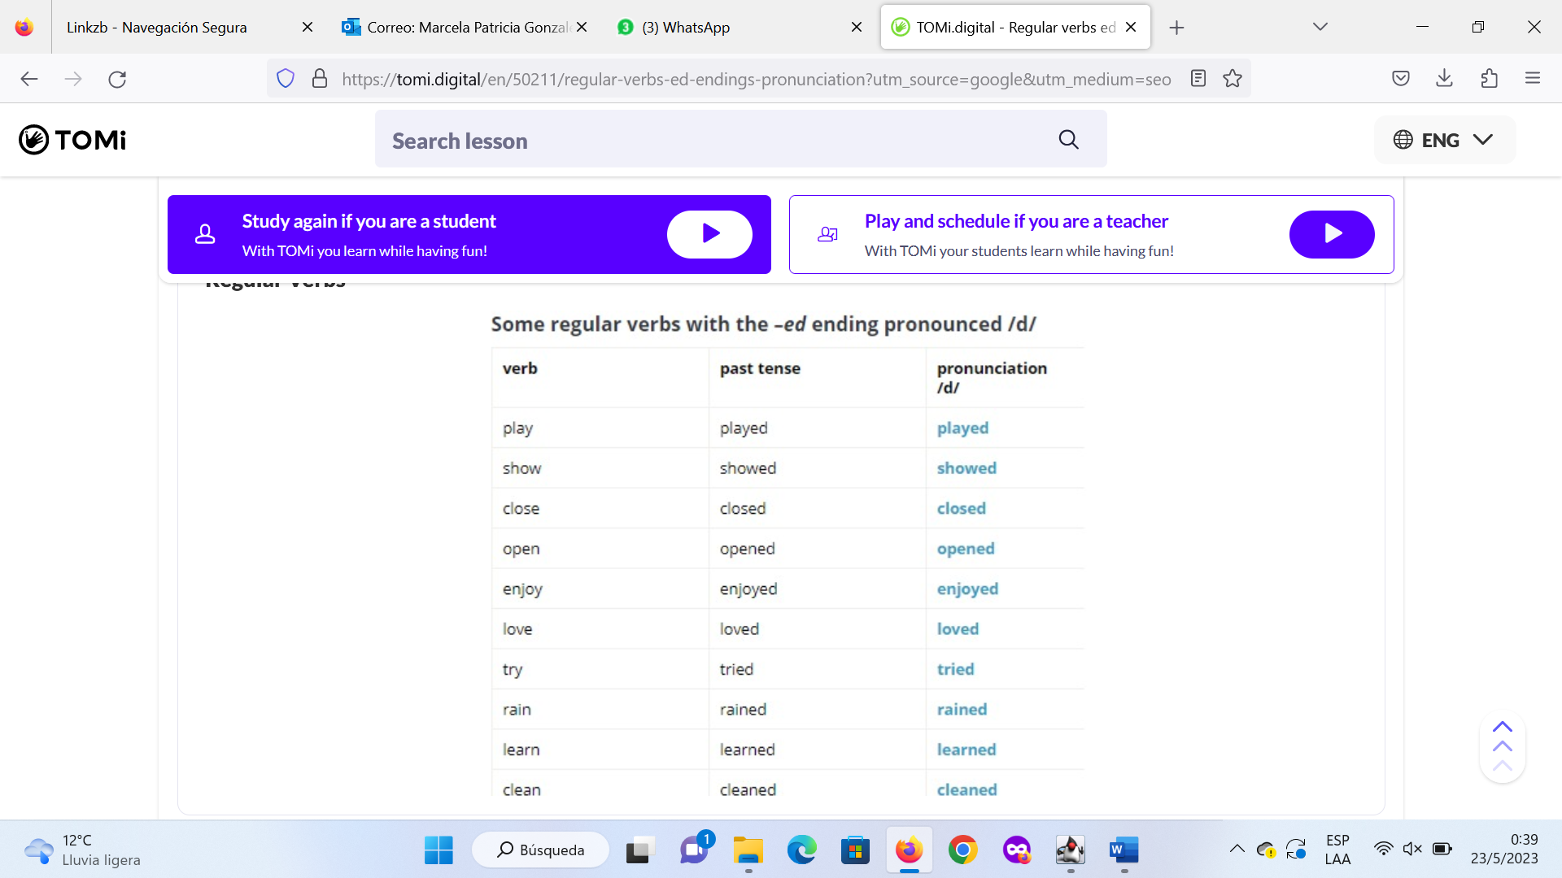

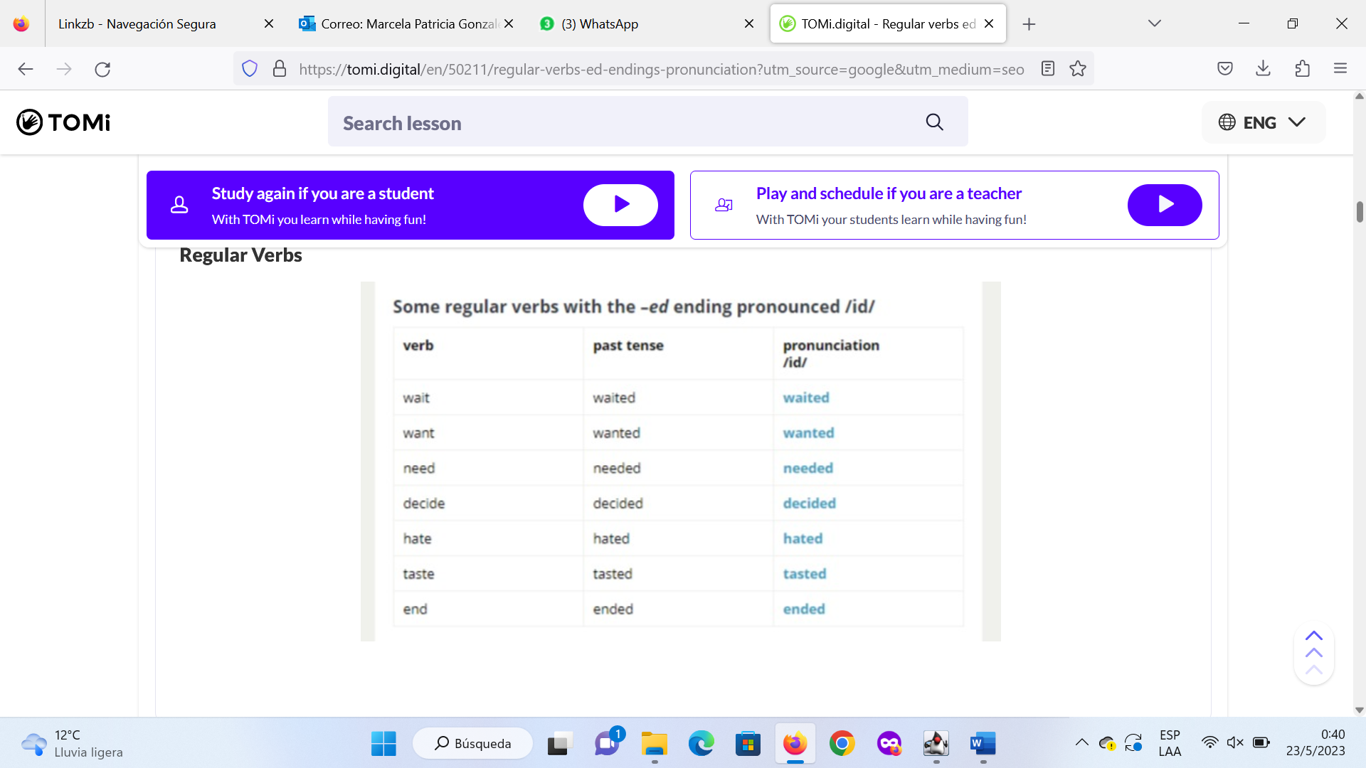

**TV show**

**Verbs to add “ED”**

[**https://es.liveworksheets.com/worksheets/en/English_as_a_Second_Language_(ESL)/Regular_verbs/Verbs_add-_ed_ll1885777hn**](https://es.liveworksheets.com/worksheets/en/English_as_a_Second_Language_(ESL)/Regular_verbs/Verbs_add-_ed_ll1885777hn)