**UNIT 5**

**PHOTO STORY**

**Task 1. Read the dialogue below, explain who they are and what they are talking about.**

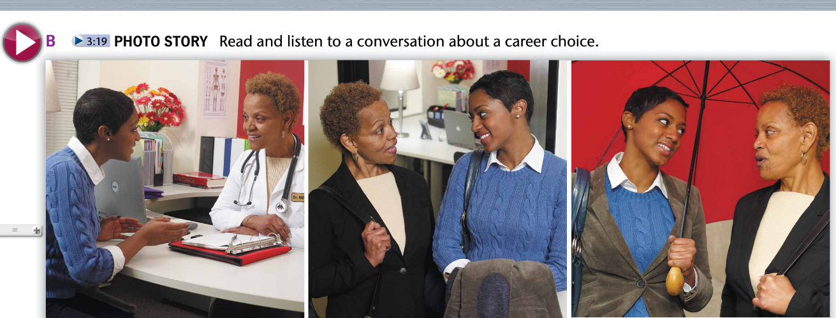

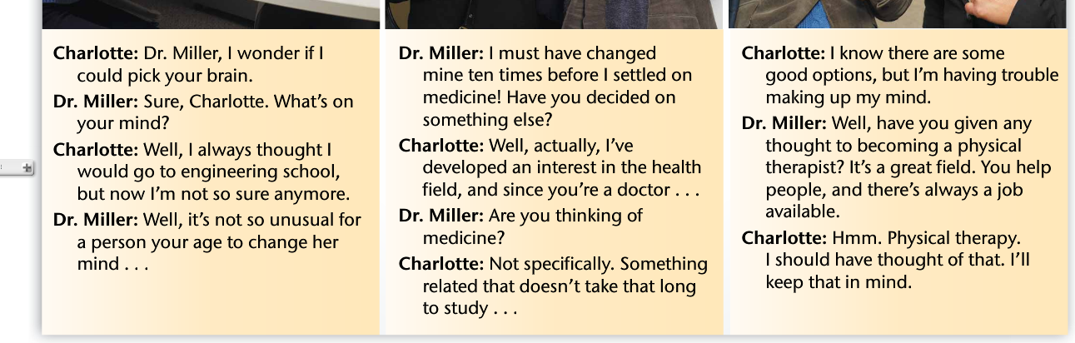

**Task 2. Develop activity C.**

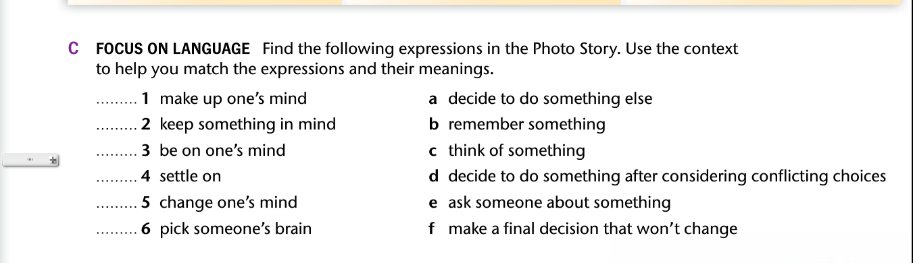

**SPEAKING**

**Task 1. Answer these questions.**

1. **Have you ever changed your mind about any plan?**
2. **Have you ever changed your mind about your career?**
3. **Have you ever changed your mind about a relationship?**