**UNIT 1**

**NOW YOU CAN**

Task 1. Present the survey.

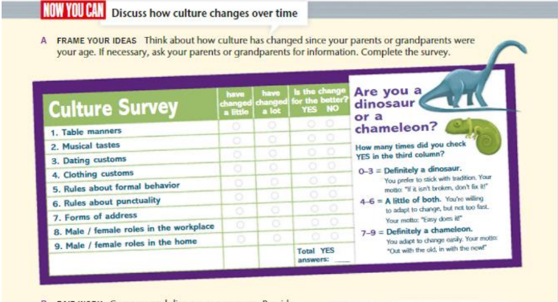

Task 2. Provide your answers and explain them.

