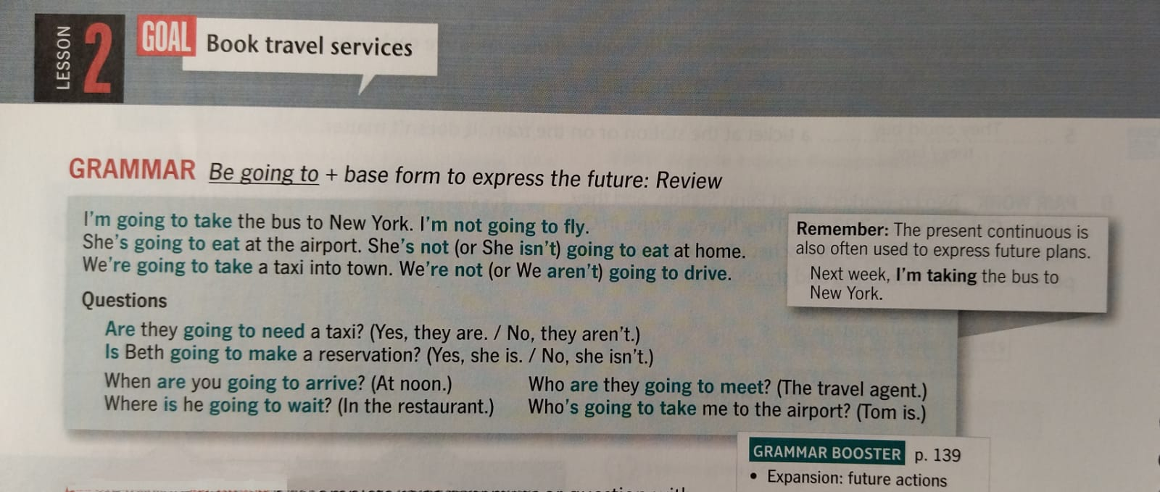

1. **A GRAMMAR PRACTICE Complete each statement or question with be going to and the base form of the verb.**
2. ................................................ tickets for (they / not buy) the express.
3. When .......................................................(she/ leave) the airport?
4. ......................................... (you/ ask) for an aisle seat?
5. Who...............................................(take) the train station?
6. Who .................................................... (he/call) in Chicago?
7. Where .................................... (dad/be) when I arrive?
8. **Complete the e-mail. Circle the correct verb forms.**

Here's my travel information: I (*go to leaving /'m going to leave*) Mexico City at 4:45 P.M. on Atlas Airlines flight 6702, and I'm arriving in Chicago at 9:50 P.M. Mara's flight (*is going to get there/ going to get there*) ten minutes later, so we (*'re go meeting/´re going to meet*) at the taxi stand downstairs. That's too late for you to come to the airport, so we can take the express bus from O'Hare to the city. Mara (*goes to spend / is going to spend*) the night at our apartment. Her flight to Tokyo isn't leaving until the next day, and she and I (*are going to spend / going to spend*) the whole day shopping!

1. **PAIR WORK: Ask your partner three questions about**

**his or her future plans. Use be going to.**

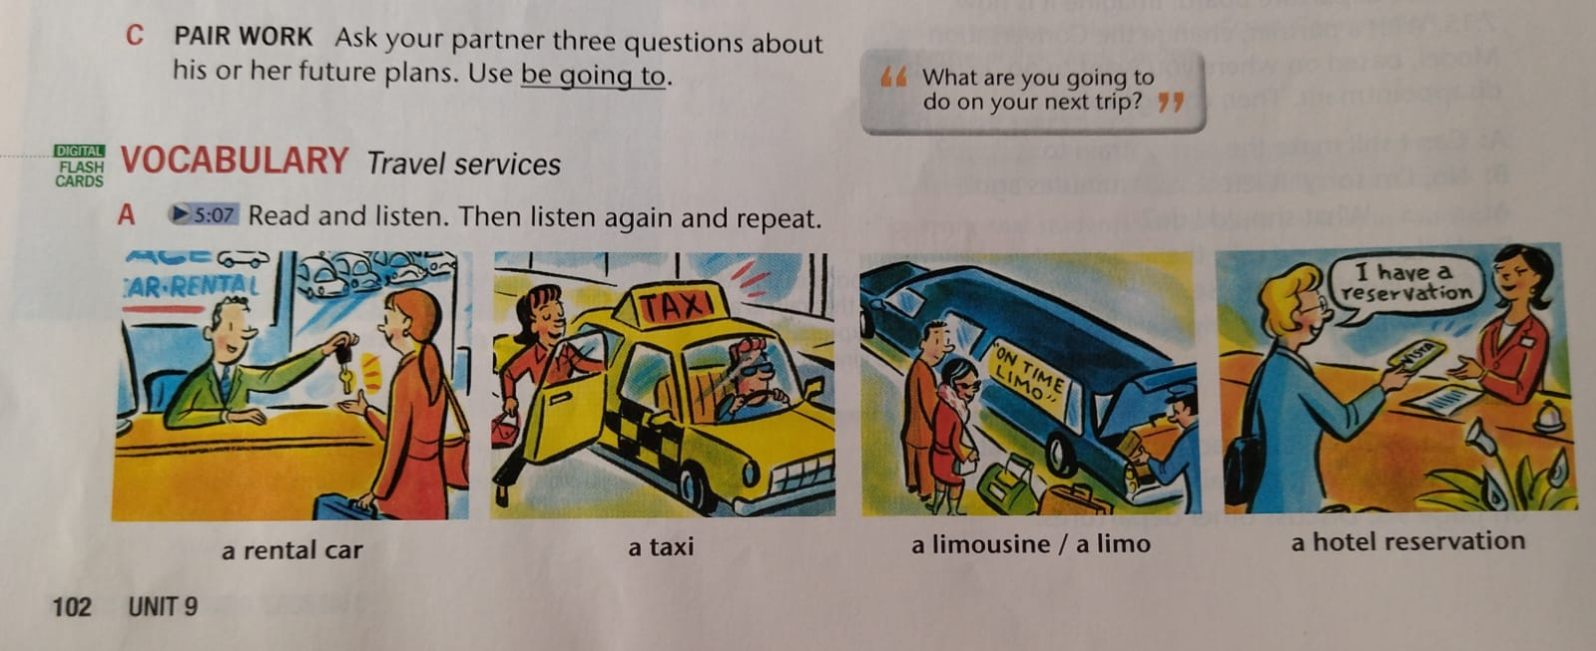

1. **LISTEN TO INFER Listen to the conversations. Then listen again and complete each sentence with be going to and infer the name of a travel service.**
2. He ..................... (reserve) ......................for her.
3. The tourist ........................... need ................................ in Seoul.
4. She ................................ (get) at John F. Kennedy Airport.
5. The agent ................................... (check) see if he can reserve ............... for the tourist.

