**UNIT 4**

**VOCABULARY 1**

**Task 1. Present the vocabulary. Use Tophonetics platform to know the correct pronunciation of these words.**

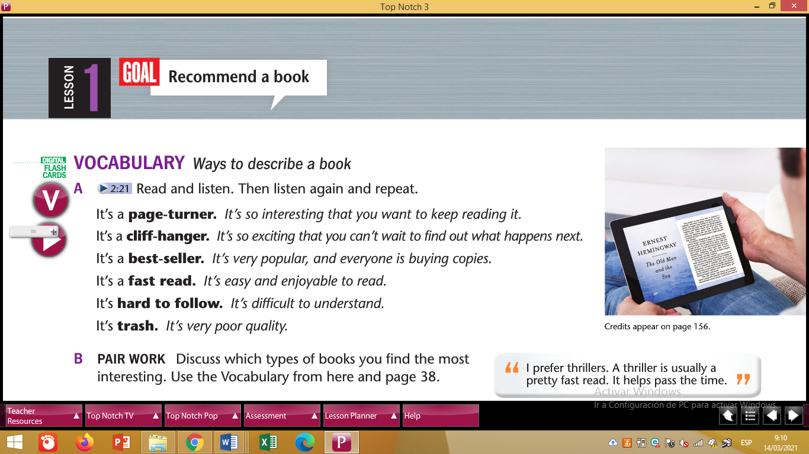

**Create a game to practice the new vocabulary words.**

**Task 2. Give an example of a book for each characteristic using Noun Clauses. Use a picture for each example.**

**For instance:**

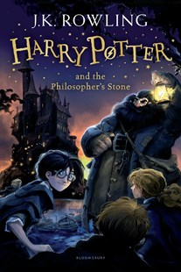

* **I am sure that Harry Potter and the Philosopher’s stone is a cliff hanger book.**