**PHOTO STORY**

**Task 1. Read the dialogue and give a summary about it, please include who are in it.**

**Task 2. Develop D and E activities.**

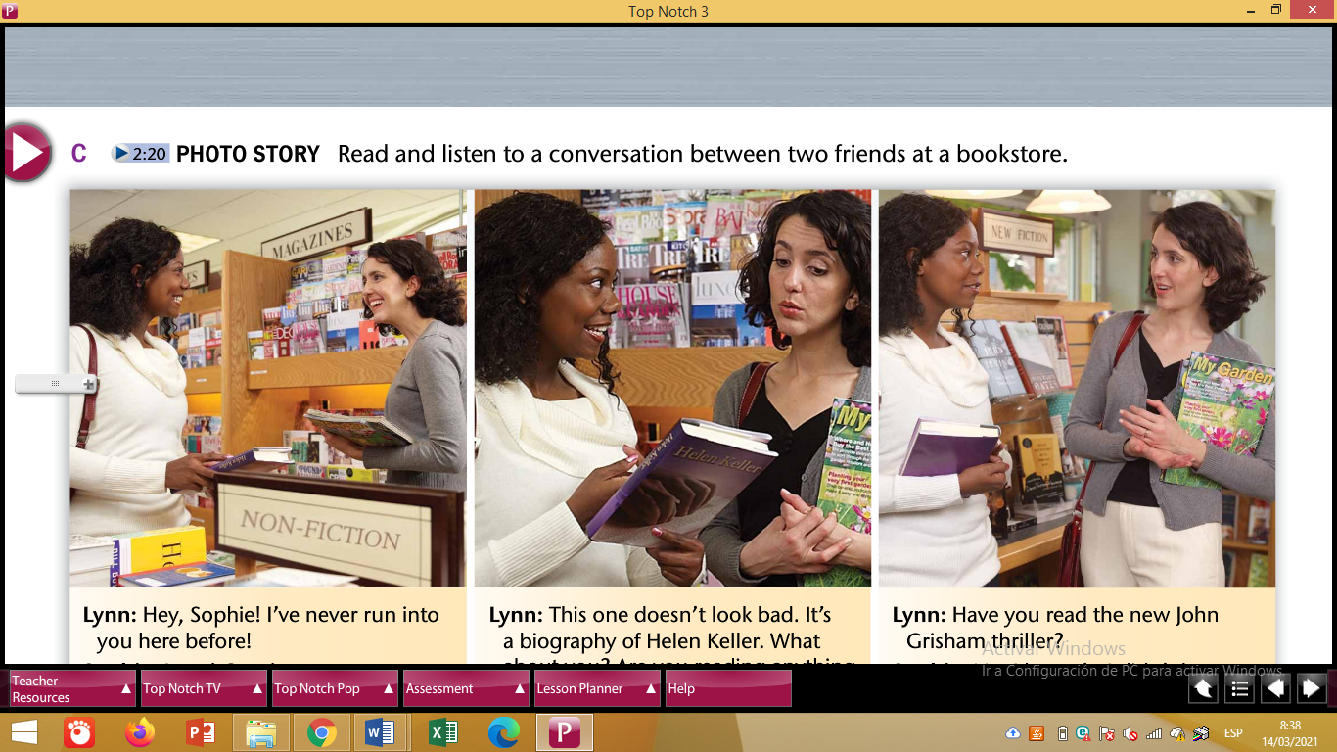

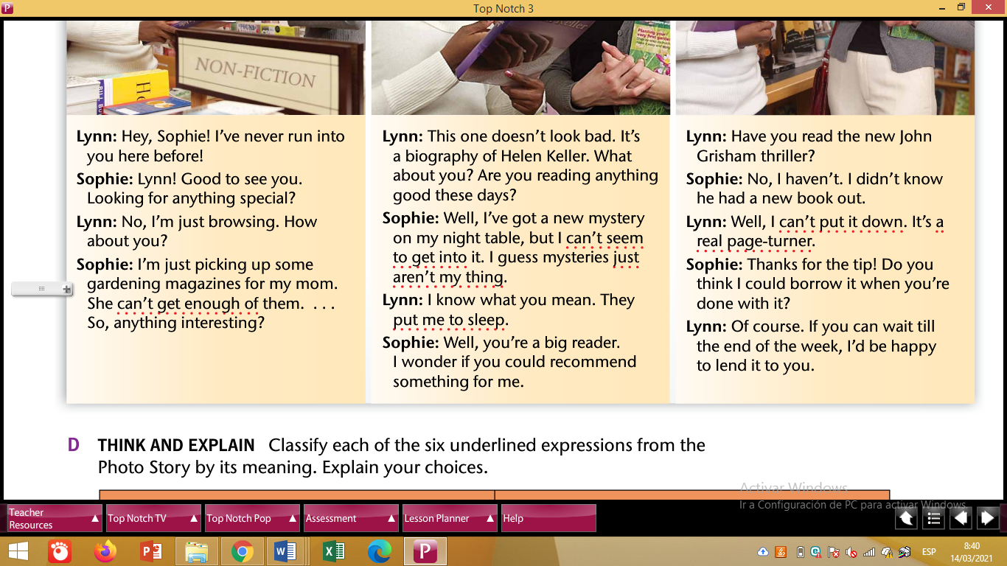

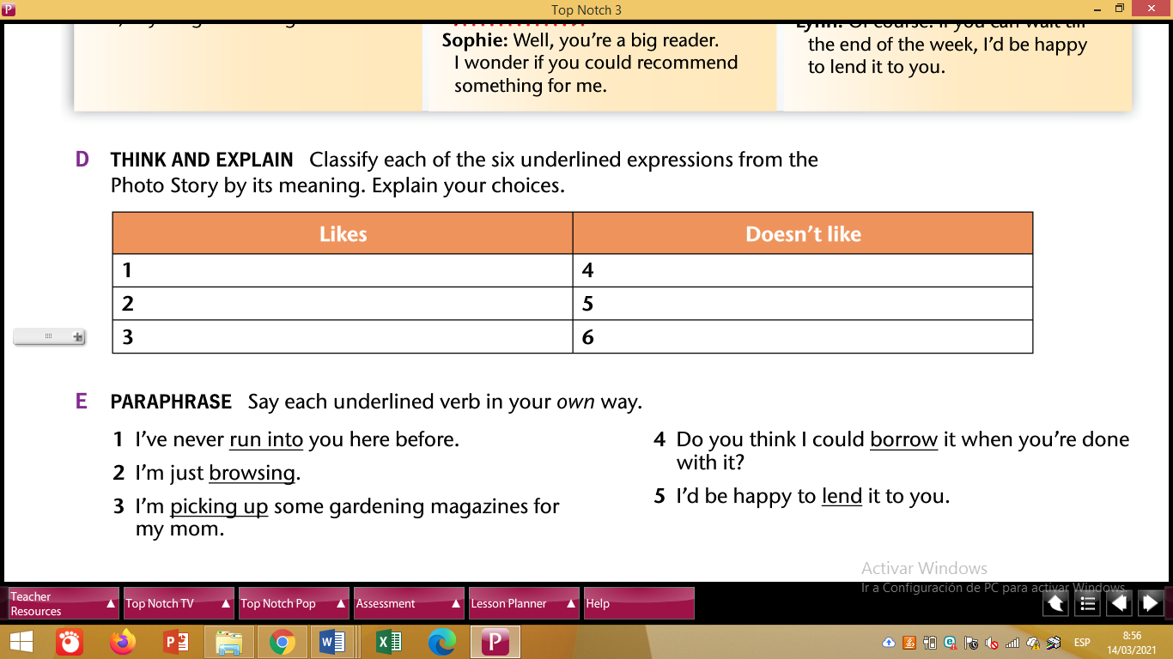

**Note: Activity E is to look for a synonym verb.**