**UNIT 5**

**NOW YOU CAN**

**Task 1. Fill the information below, use the information in the Reading.**

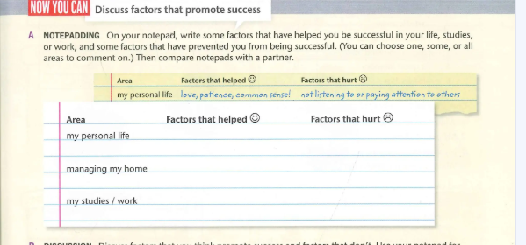

**Task 2. Analize you and your skills, abilities and qualifications.**

**SUMMARY**

**Task 3. Based on the previous information, write about your talents, skills, knowledge and experience. Use the sentences below.**

____________________________________________________________________________________________________________________________________________________________________________________________________________________________________________________________________________________________________________________