**UNIT 4**

**VOCABULARY 2**

**Task 1. Present the vocabulary. Use Tophonetics platform to know the correct pronunciation of these words.**

**SOME WAYS TO ENJOY READING**

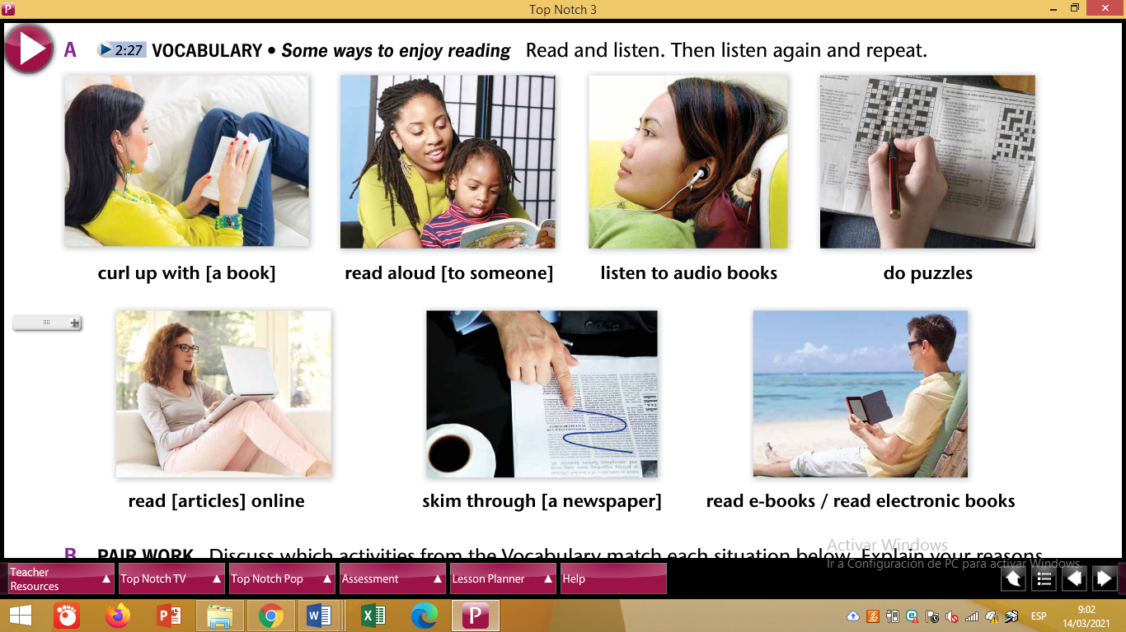

**Create a game to practice vocabulary.**

**Task 2. According to the vocabulary above do activity B. Use Noun Clauses**

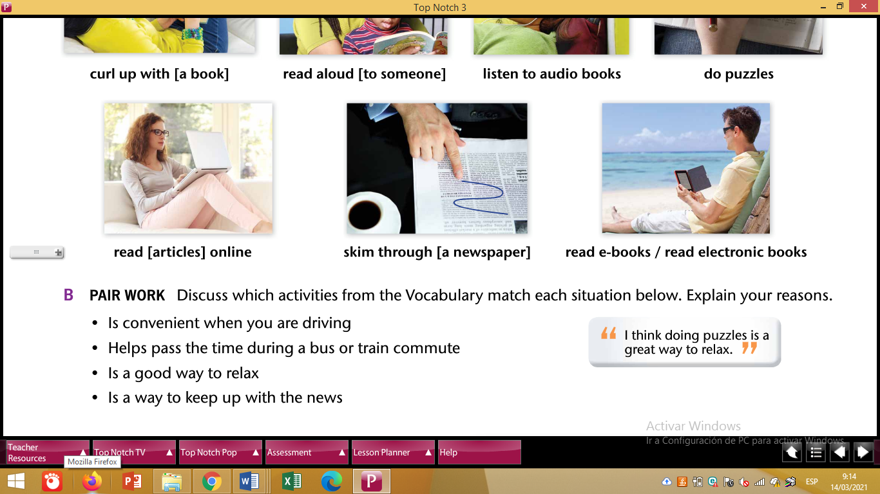

Example: I think that **listening to audio books** is convenient when you are driving.

1. _____________________________________________
2. _____________________________________________
3. _____________________________________________