**COMPARATIVE ADJECTIVES**

Look at the pictures and use the comparatives.

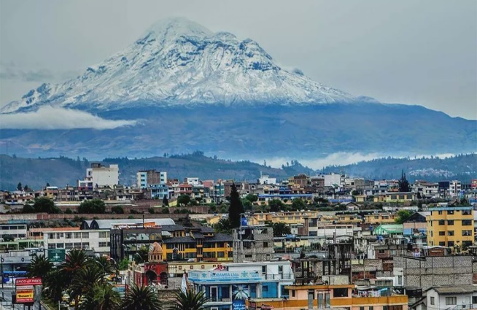**RIOBAMBA TOWN LOJA TOWN**

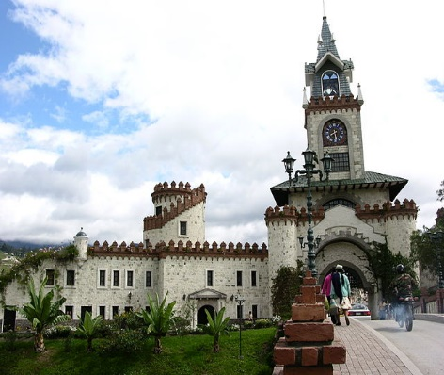

1 SYLLABLE ……………………………………………. …………………………………………

+ TWO SYLLABLES ……………………………………. ……………………………………………

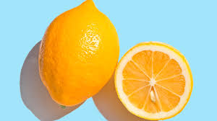 **Oranges Lemons**



 

 