**UNIT 5**

**PREVIEW**

**Task 1. Explain what it is in this interview.**

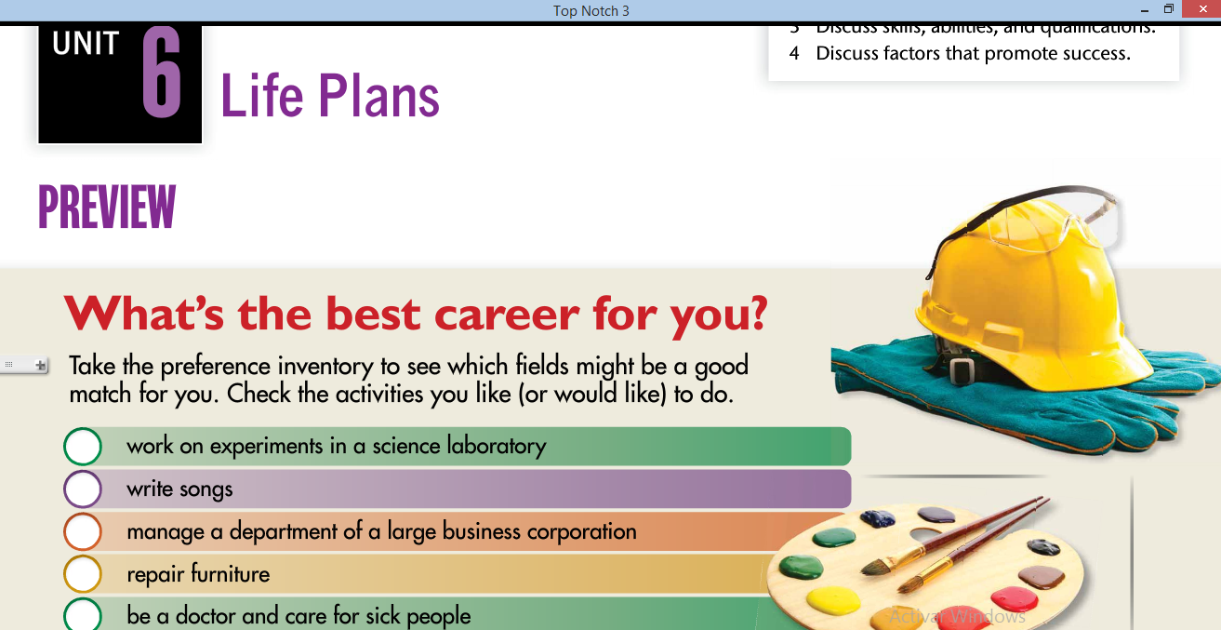

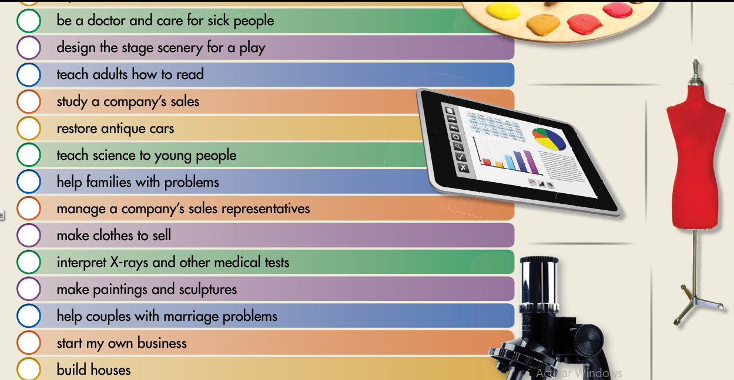

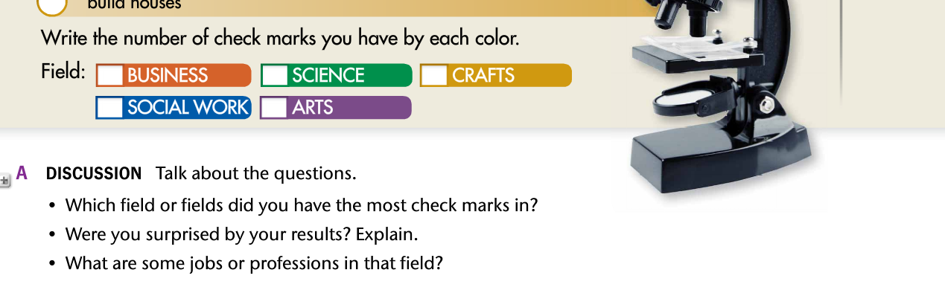

**Task 2. Answer the following questions.**

