**VOCABULARY OF UNIT 3**

**Task 1. Present the vocabulary. Use Tophonetics platform to know the correct pronunciation of these words.**

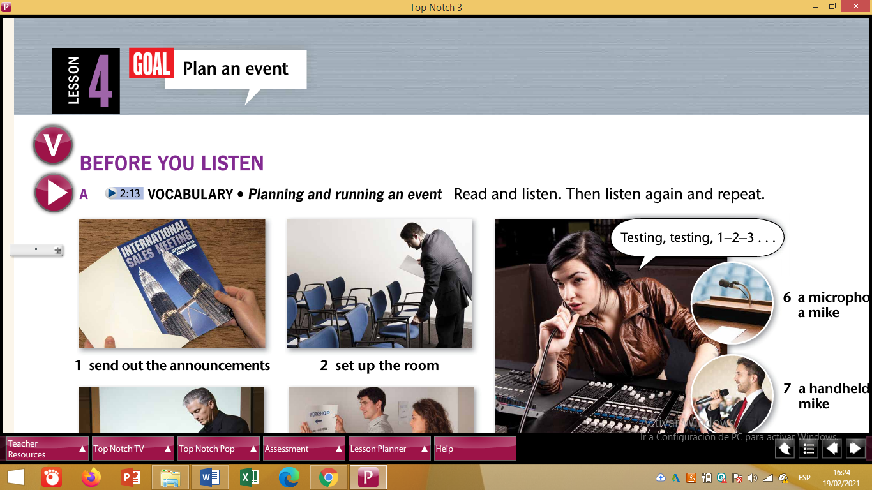

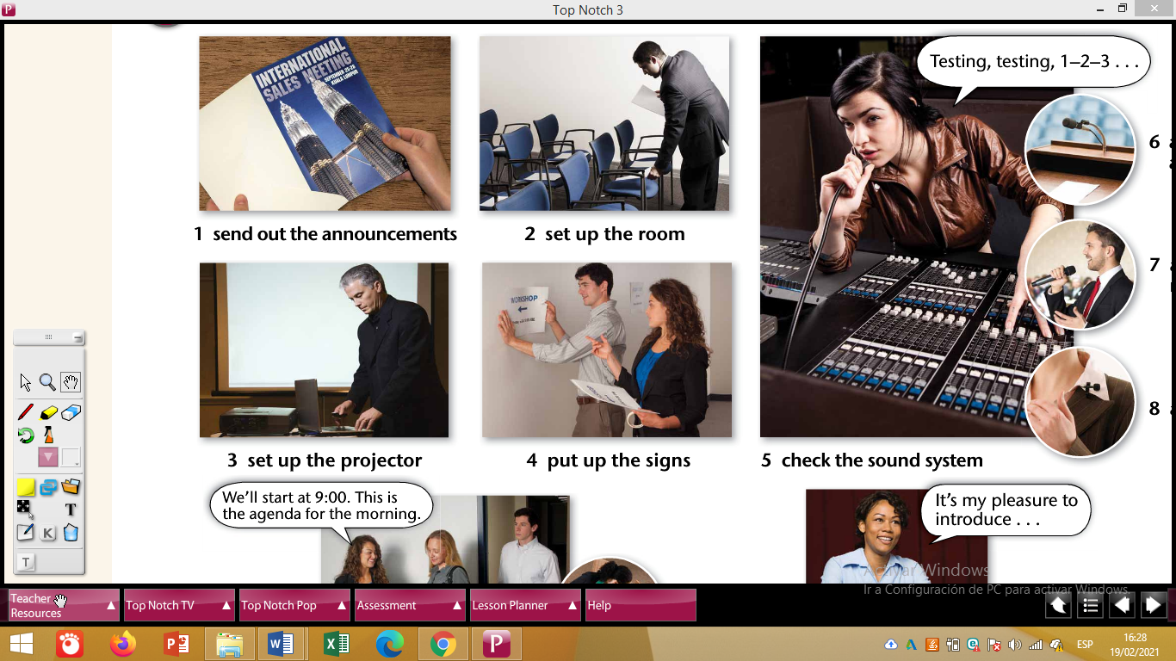

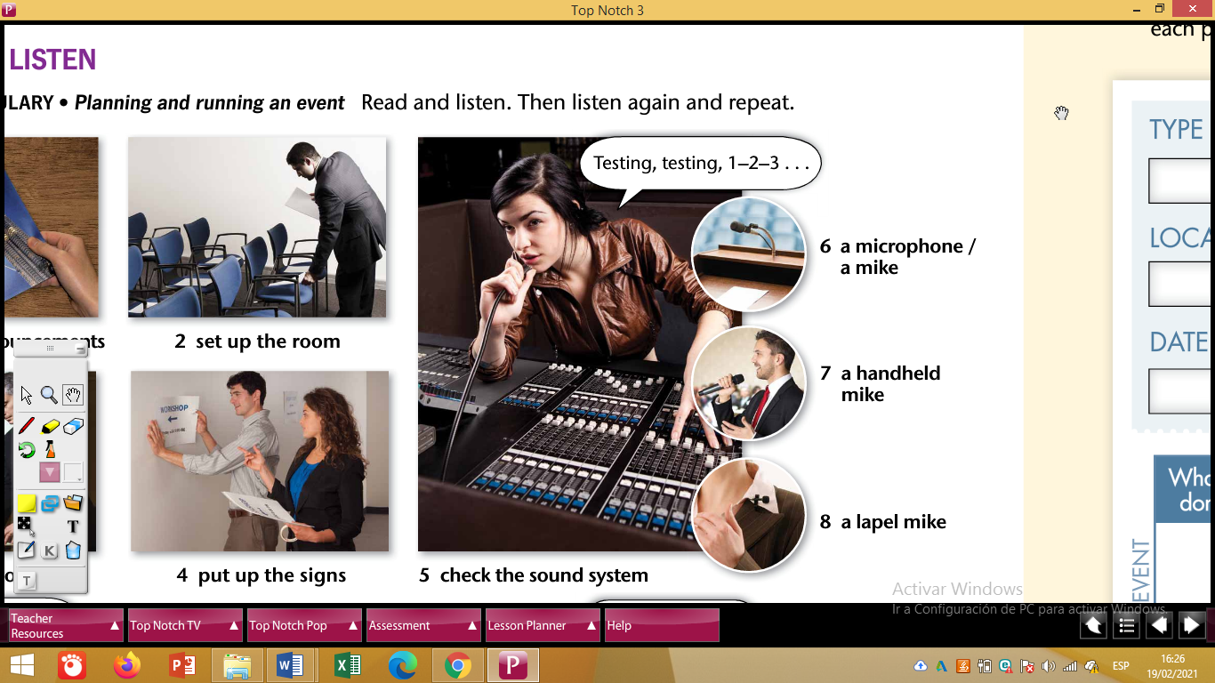

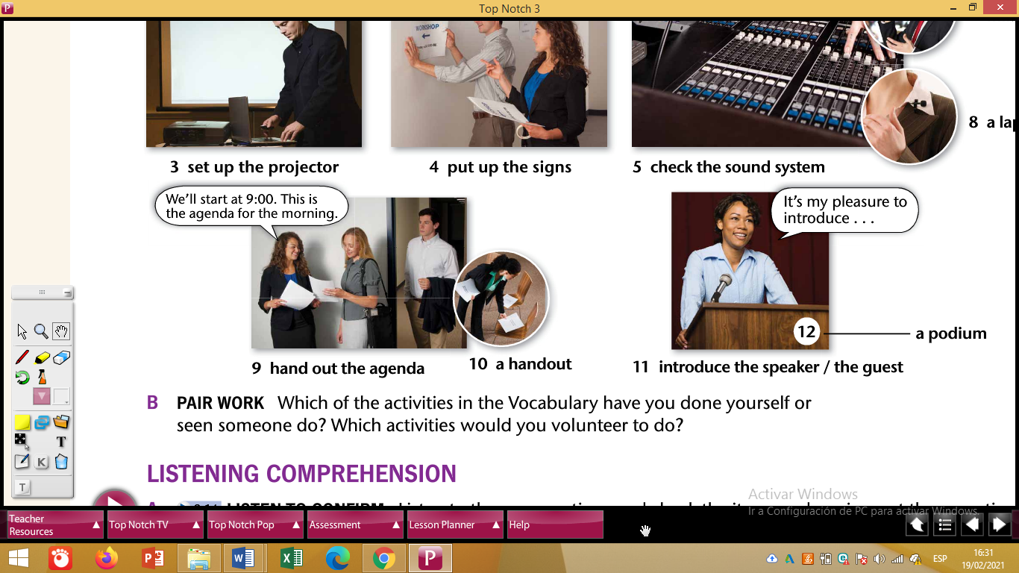



**Task 2. Create a GAME for your partners to guess or complete words based on the Vocabulary.**

**Task 3. Write examples using Causatives and Vocabulary. (5 sentences)**

**Topic: Organizing a webinar.**

* **The professors got the students to send out the announcements**