**UNIT 4**

**INTRODUCTION**

**Task 1. Explain what Reading for Pleasure means.**

**Task 2. Present kinds of books, use Tophonetics platform to get a correct pronunciation.**

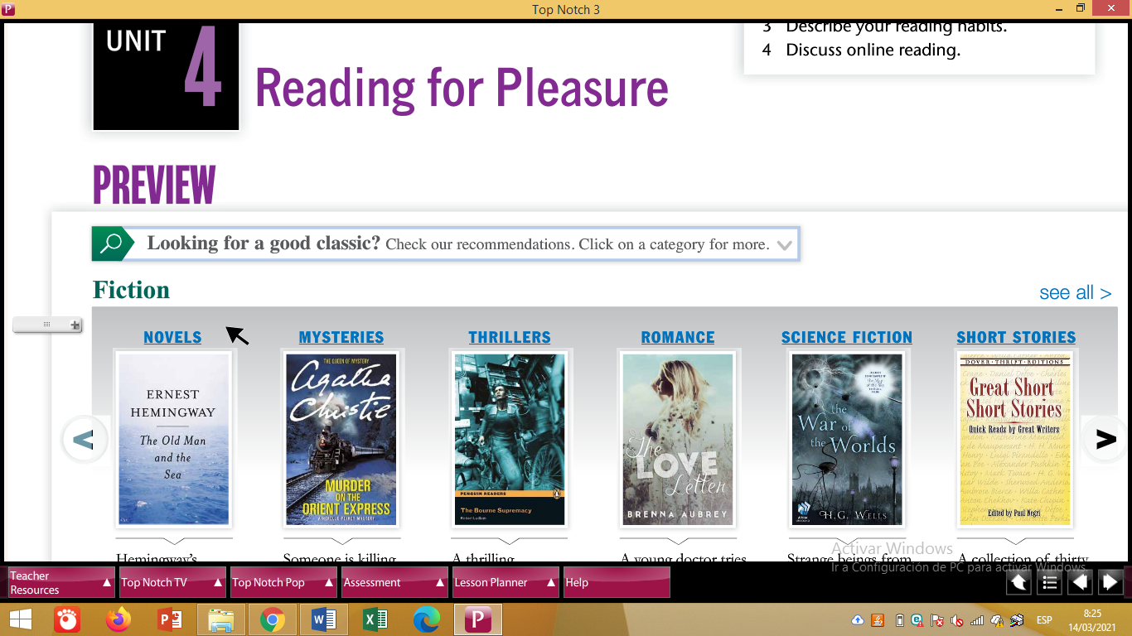

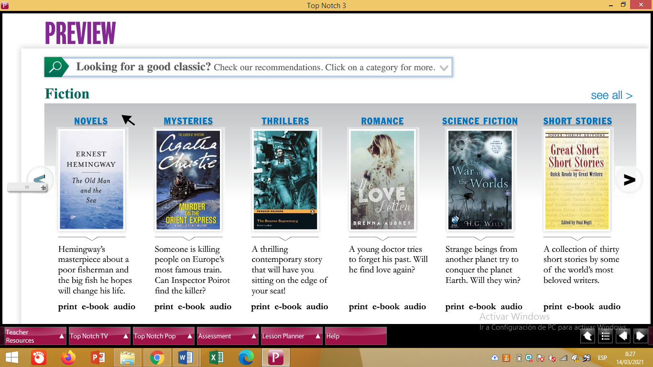

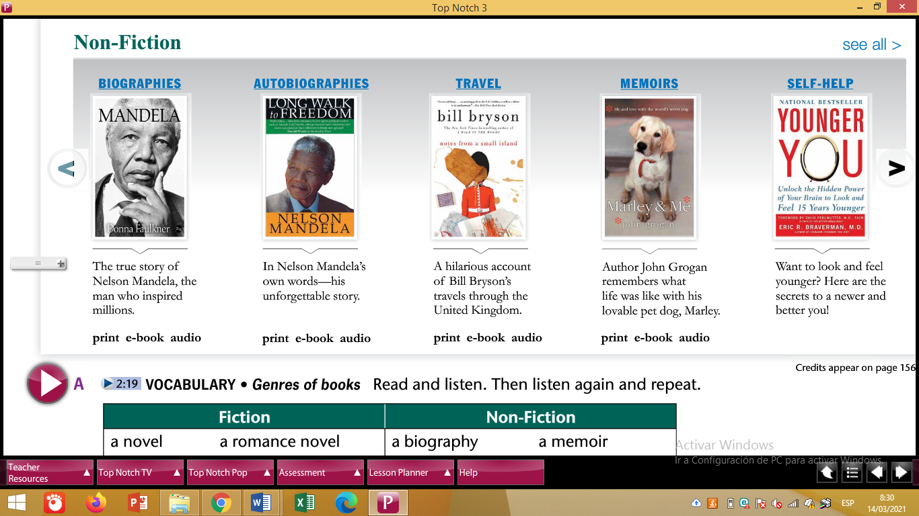

**Task 3. Answer these questions.**

1. **Do you like to read for pleasure?**
2. **How many books have you read?**
3. **What kind of books do you prefer?**